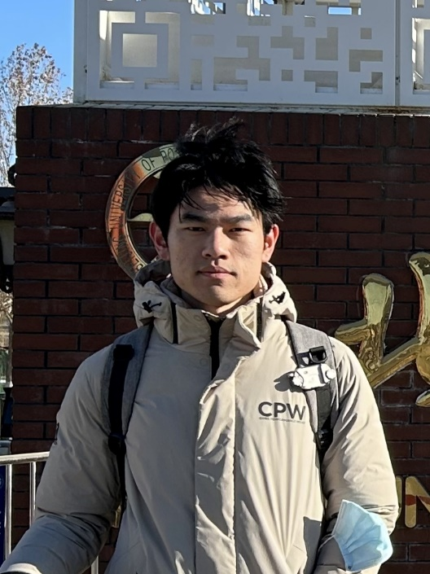

Zecheng Li – Penn Bioengineering Master’s Student

Zecheng is a first-year master’s student in Bioengineering. Before coming to Penn, he received a B.S. in Bioengineering from UC San Diego. His current research focuses on exploring relation between collagen self-assembly and poroelasticity of hydrogels. Outside of the lab, he enjoys photography, bouldering, and swimming.